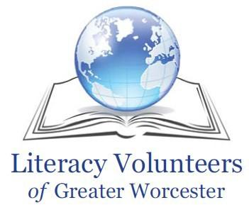
Literacy Academy Winter Schedule of ESL Courses
January 23 – April 24, 2017

Beginner Courses
Monday | Tuesday | Wednesday | Thursday | Friday | Saturday
ESL Beginners  Rosetta Stone  9:30-11:00 a.m.  Instructor: TBA  WPL 3rd Floor Computer Lab | ESL Survival  Rosetta Stone  9:30-11:00 a.m.  Faith Landrine  WPL 3rd Fl Computer Lab | ESL Beginners  Rosetta Stone  9:30-11:00 a.m.  Celeste Steffancci  WPL 3rd Floor Computer Lab |  | ESL Beginners 2  9:30-11:00 a.m.  Faith Landrine  Madison Place Satellite
ESL Beginners  Rosetta Stone (Kindle Fire)  6:00-8:00 p.m.  Robert Peters  Madison Place Satellite |  |  |  |  | ESL Beginners  Rosetta Stone  3:30-5:00 pm  Instructor: TBA  WPL 3rd Fl. Computer Lab

Intermediate Courses
Monday | Tuesday | Wednesday | Thursday
ESL Intermediate  Helping Your Schoolchild  9:30-11:00 am  Amy West  Madison Place Satellite | ESL Intermediate  Reading and Writing  9:30-11:00 am  Susan Palis  Madison Place Satellite | ESL Intermediate  English for Work: Conversation  9:30-11:00 am  Susan Palis  Madison Place Satellite | ESL Intermediate  Listening and Speaking  9:30-11:00 a.m.  Celeste Steffancci  Madison Place Satellite
 | ESL Intermediate  Conversation  11:30 am – 1:00 pm  Sarah Lyon  Madison Place Satellite | ESL Intermediate  Reading Your Local Newspaper  11:30 am – 1:00 pm  Celeste Steffancci  Madison Place Satellite
ESL Intermediate
6:30 – 8:00 pm
Instructor: TBA
Madison Place Satellite
Registration will be held January 3-13, 2017. Students must register in person at our main office.
Students may register for no more than 2 courses. Courses are free. We suggest a donation of $25 to attend 1 course and $35 to attend 2 courses. This is a 12-week semester. Weekly attendance is expected.

Main office is located at Worcester Public Library, 3 Salem Square, Room 332, Worcester, MA 01608.
Call 508.754.8056 or email info@lvgw.org with questions.

