**Following Directions**

Materials: Following Directions, Map (separate document), Map Directions, Prescription and Over the Counter (OTC) Medicines, Common signs and symbols.

Objectives: Students will know how to listen to, follow and give simple verbal directions, they will be able to read and follow simple directions on home products and prescription bottles, they will be able to recognize and understand common signs and symbols.

1. In this class you will be discussing the many types of directions people follow each day. Some directions we read, some directions we hear, and some directions we must interpret by translating symbols. First, start out by giving each student the Following Directions form to fill out. See how many students read all the directions first!!!

2. Ask the students to think of all the directions they follow in a week. Have them work with a partner to come up with a list. You can give them the example of following a recipe, which is a set of directions.

3. Ask for volunteers to share their lists. Write their answers on the board. Make sure that you have a complete list of all their suggestions. Make sure that they have all the examples from the Types of Directions List which you can use as a reference.

4. Choose an example from the list and ask the students why it is important to follow those directions. For example, it’s important to follow the directions on a recipe so your food will taste good and be cooked properly, it’s important to follow directions when you’re trying to get to a specific location so you don’t get lost, and it’s important to follow directions (road signs) when you’re driving so you don’t cause accidents or get stopped by the police! This is a good to point out that sometimes not following direction just causes small problems, but sometimes it can cause serious injury or even death!

5. Tell the students you are going to ask them to listen to and follow some directions that are often given in a classroom. Add to the following any directions that you find relevant:

a. Raise your hand if (you speak Spanish, you live in Worcester, you have children, etc.)

b. Could everyone please (stand up, push your chair in, choose a partner, sit down, take out a piece of paper, turn your paper over, etc.)

c. NOTE: Sometimes directions are not stated but implied. For example I might ask, “How many people here live in Shrewsbury?” What do I expect you to do?

6. Next, hand out the map and map directions. Review with the students the vocabulary for giving directions. If there is room in the classroom you might ask for a volunteer to stand and take directions from the other students. They can tell the volunteer to walk straight ahead, turn right, etc. and ask the volunteer questions like, “What are you near?, What is in front of you?”

7. Then have the students work in pairs, each taking a turn to give and take direction. Walk around and monitor the class to see what, if any, problems the students are having. When everyone has had a chance to go through the list ask for feedback. What did the students find to be easy? What was difficult? What do they need more practice doing? Spend time reviewing any directions that students had difficulty following.

8. Hand out a copy of Prescription and Over the Counter (OTC) Medicines to each student. Ask the students if medicines are easier to buy in their home country than in the US. In many countries more medicines are available OTC than in the US. Ask if our prescription labels are easy or difficult to understand. Have the students take turns reading the handout aloud. Let them ask questions as they read. Emphasize that pharmacists are always happy to answer questions about medications.

9. Next ask the students about the types of cleaning products they use in their homes. Do they use types of cleaners for different jobs? Do they read the directions and warnings on their cleaning products labels? Did they know that if they mix certain household chemicals together they can create harmful, even deadly fumes (strong smelling or odorless gas)? Have them read the **Dangerous Cleaning Product Combinations** section aloud and ask any questions they have.

10. Have the students read the last **warning** on the handout. Ask the students if they use outdoor heaters or cooking grills. Have they read all the directions? You can let them know that every year there are deaths in the US caused by using heaters or cooking grills indoors that are meant to be used outside.

11. Lastly, give each student the Common Signs and Symbols handout. Have the students seen these? Where have they seen them? Do they know what they mean? Ask the students to tell you about each sign or symbol. For a more complete set you can use the section in THE ESL MISCELLANY by Pro Lingua Associates.

Types of Directions

Written directions: recipes, medicine bottles, cleaning products, heating equipment (some heating equipment is not meant to be used indoors and can cause death if used in an unventilated area, this is also true for some types of cooking grills and all charcoal grills), all types of forms (medical, credit card application, etc.)

Directions you hear: in class, when asking for directions to find a specific location, when asking for help to find a specific object in a store, if you are stopped by the police

Symbols to interpret: traffic signs, maps, signs in building (restrooms, escalators, etc.)

Following Directions

1. Read all the directions before you write anything.

2. Write your first name here ___________________________________.

3. Write your last name here. Use all capital letters. _________________________________.

4. Enter today’s date here_________________________________________.

5. Are you married? Circle YES or NO.

6. Fill in only line 2 and then turn your paper over.

Following Directions

1. Read all the directions before you write anything.

2. Write your first name here ___________________________________.

3. Write your last name here. Use all capital letters. _________________________________.

4. Enter today’s date here_________________________________________.

5. Are you married? Circle YES or NO.

6. Fill in only line 2 and then turn your paper over.

Following Directions

1. Read all the directions before you write anything.

2. Write your first name here ___________________________________.

3. Write your last name here. Use all capital letters. _________________________________.

4. Enter today’s date here_________________________________________.

5. Are you married? Circle YES or NO.

6. Fill in only line 2 and then turn your paper over.

**Map Directions**

There is more than one way to get to your destination.

1. You are standing on Main Street in front of CVS. Ask your partner how to get to the Florist Shop on North Street. What is CVS next to?

2. You are at McDonald’s on Elm Street. Ask your partner how to get to the Card Shop on North Street. What is the Card Shop in between?

3. You are in the parking lot at the Post Office. Ask your partner how to get to the Mini Mart on Main Street. What is across the street from the Mini Mart?

4. You are at the Dry Cleaners on North Street. Ask your Partner how to get to Kinko’s on Main Street. What is in back of Kinko’s?

5. You are in the parking lot at Dunkin’ Donuts. Ask your partner how to get to the pond at Maple Park. What is across Maple Street from the park?

6. You are at the Hospital’s Main Entrance. Ask your partner how to get to the gas station on North Street. What is the gas station near?

Some vocabulary for giving directions:

Go straight ahead

Cross the street

Go past the…

Go two blocks

Turn right, turn left

On the corner of

Next to

Across the street from

In between

Near

In back of, in front of

Other

Prescription and Over the Counter (OTC) Medicines

If you do not understand the **directions** on a medicine bottle ASK THE PHARMICIST to explain it to you!!!!! Many people have difficulty understanding these directions because they are not written clearly. Do not be afraid to ask for help.

Read the **warnings**!!! On some OTC medications there are warnings about the maximum number of doses you can take in a day. Other warnings may include how to take the medication, for example: take on an empty stomach, take with meals, drink a full glass of water, do not lie down after taking, do not take with alcohol, do not take if pregnant or breastfeeding, do not take with other medications……

Read the section for **other information.** Sometimes this tells you how to store the medication. Some medications must be stored in the refrigerator, others must be stored at room temperature, etc. Over the Counter (OTC) – medicines you can buy without a prescription Once daily or once a day = one time a day Twice daily or twice a day = two times a day Dose – a measured amount of medicine to be given at one time. Dosage - the amount of a medicine that should be taken at one time OR regularly during a period of time. \***NOTE**: Most prescription and OTC medicines warn not to exceed (to take more than) the prescribed or recommended dosage. Many OTC medicines have different recommended dosages for children. When you have questions about a dosage, ask your doctor or pharmacist!!

tsp or t = teaspoon Tbsp. or T = tablespoon fl oz = fluid ounce qty = quantity

cap = capsule tab = tablet

drug exp = drug expiration (date) after this date the drug is no longer effective

refills = the number of times you can call the pharmacy to get more medicine without needing a new prescription

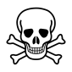 **Dangerous cleaning product combinations **

Never mix bleach with vinegar, ammonia, or rubbing alcohol.

Never mix vinegar and hydrogen peroxide.

Read the directions on all cleaning products you use.

**Another Warning:** Do not use heaters or cooking grills in the house that are meant to be used outside.They can produce **odorless, but deadly, fumes!!!**

Common Signs and Symbols

 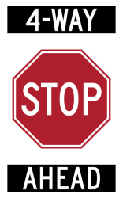 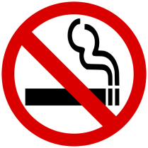 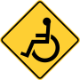

2

3

4

1

8

7

6

5

 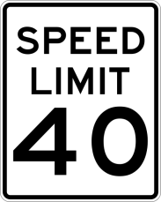 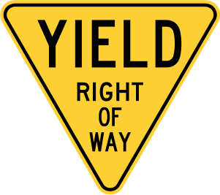 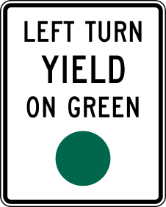

10

9

11

 

EMERGENCY EXIT ONLY

ALARM WILL SOUND

12

15

14

13

