Doctors Visits
Materials: Diagram of body, Vocabulary 1 and 2 (on back of page), Descriptions of pain and sickness/ Making sentences (on back of page), Talking to Your Doctor
Objectives: Students will be able to describe their symptoms to their doctors.
Vocabulary: See Vocabulary handout.
1. Tell the students that today you will be talking about visits to the doctor. Ask the students if they would like to share a story about a trip to the doctor’s. Ask if it was easy or difficult to explain their problem to the doctor. Ask if it was easy or difficult to understand what the doctor was asking them. Let everyone have the opportunity to share a story.
2. Give each student the handout with the body outlines. Ask them to label as many of the body parts as they can. You can demonstrate that on the front of the head they can label eyes, nose, etc., even though those parts are not drawn in.
3. Once everyone is done, ask the students to tell you what they labeled on the head. If they missed any of the parts you have on the vocabulary list, point to the part and ask them what it is. They can then label this part on their diagram. Follow this routine for the rest of the sections of the body.
4. Hand out the Descriptions of Pain and sickness/Making sentences. Have the students read all the descriptions under the pictures and the formula “part + ache”. They can then turn the paper over and as a group or individually write their sentences.
5. Hand out the Vocabulary paper and have them look at the bottom section. Have the students read the descriptions of pain and sickness. Ask them to add any others they have used.
6. Have the students turn the paper over and read Kinds of pain. Ask if everyone understands all the descriptions and clarify when needed. Ask the students to write a description of their last sickness. When they have finished, ask for volunteers to read what they wrote.
7. If you have time you can have two students read the “Talking to Your Doctor” dialog. Ask if other students would like to role play a conversation using their own questions and answers.
8. A good homework assignment would be for them to write another description of when they or their child was sick.

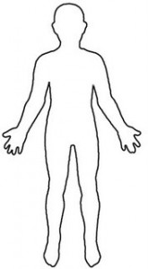
Back of Body
Front of Body
Diagram from Windows Clip Art
Label as many body parts as you can.
Descriptions of pain and sickness (illness)

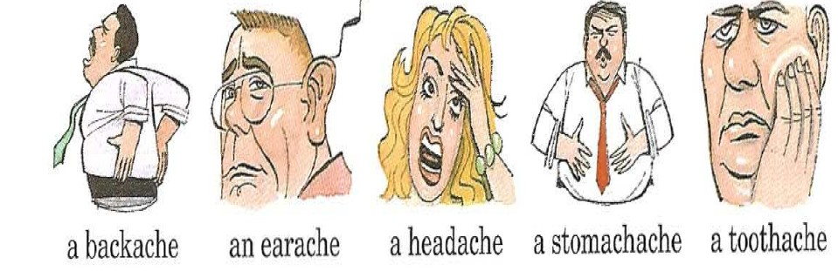
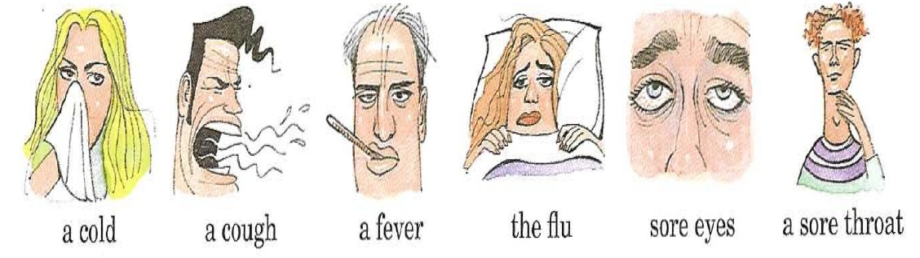

"part+ ache" means this part hurts. "ache" means hurt.
Back+ ache = a back hurts head + ache = a head hurts
Ear + ache = an ear hurts stomach + ache = a stomach hurts
Tooth + ache = a tooth hurts

Adapted from ProjectSHINE.org Health Literacy Lessons Fall 2012 teacher version

Make sentences using "I have a/an..." and "My ... hurts".
E.g. A backache
I have a backache. = My back hurts.

An earache
______________________________ = ____________________________________

A headache
______________________________ = ___________________________________

A stomachache
_______________________________ = __________________________________

A toothache
_________________________________ = _____________________________________

A sore throat
__________________________________ = ________________________________________

Adapted from ProjectSHINE.org Health Literacy Lessons Fall 2012 teacher version

Vocabulary 1
Head: face, forehead, temples, cheeks, chin, nose, nostril, eyes, eyelids, ears, jaw, teeth, tongue, lips, mouth
Neck: back of neck, side of neck, throat
Arm and hand: shoulder, upper arm, arm pit, elbow, forearm, wrist, back of hand, palm of hand, fingers, fingernails, thumb, knuckles
Front of torso: chest, breasts, abdomen, belly button, waist, pubic area, genitals
Side of torso: sides
Back of torso: upper back, mid-back, lower back, buttocks
Legs and feet: thigh (front and back), hip, knee, calf, shin, ankle, foot, toes, heel, sole of foot (bottom of foot), toenails

Muscles – join bones together, when the muscles contract (get shorter), you move.
Bones – skeleton, the hard frame of your body.
Joint – the place where two bones meet.

Common descriptions of pain and sickness:
Head: I have a headache, I feel dizzy (lightheaded), my nose is stuffed up, my nose is running, my ear is ringing, my ear is blocked, my eyes are watering, my eyes are itchy, my vision is blurry, I have a fever/temperature
Chest: I have chest pain, my heart is racing (pumping very fast), I am having trouble breathing (I am short of breath) **pronunciation alert** breathing and bleeding!
Stomach: I have a stomachache, I have been vomiting (throwing up), I feel nauseous
Intestines: I have diarrhea, I have gas
Others:

Vocabulary 2

Kinds of pain: sharp pain/stabbing pain (feels like a knife or needle jabbing into you), dull pain/dull ache (feels like something is pressing into you), throbbing pain/pulsating pain/pounding pain (feels like something is hitting you many times), persistent pain (you feel the pain all the time), intermittent pain (the pain comes and goes), mild pain (it hurts but not very much), moderate pain (it hurts and is making you uncomfortable), severe pain (it hurts a great deal)

How would you describe the way you felt the last time you were sick? For example: I had the flu. I had a pounding headache and my nose was running. I had a fever and all my muscles hurt. I felt nauseous and I couldn’t eat!
______________________________________________________________________________
______________________________________________________________________________
______________________________________________________________________________
______________________________________________________________________________
______________________________________________________________________________

Talking to Your Doctor

Read this conversation between a patient and a doctor. Sasha does not feel well and goes to see the doctor.

Dr. Smith: Hello, Sasha. How are you feeling today?
Sasha: I don’t feel well.
Dr. Smith: What’s wrong? Can you tell me how you feel?
Sasha: Well, I have a terrible headache.
Dr. Smith: Hmm…Anything else? Does your throat hurt?
Sasha: Yes, it hurts a little. I have a cough too.
Dr. Smith: Do you have a fever?
Sasha: Yes, I have a low fever.
Dr. Smith: It sounds like you may have the flu.
Sasha: Oh, that’s terrible.
Dr. Smith: Don’t worry. I will give you a prescription to help you feel better.
Sasha: Okay. Can I go to work tomorrow?
Dr. Smith: No. Stay home tomorrow, get some rest, and drink plenty of juice and water.
Sasha: Thank you, Doctor.
Dr. Smith: You’re welcome.

Adapted from ProjectSHINE.org ESL Health Unit/Advanced Beginning, Unit One: The Doctor’s Office

